FLORIDA PLANTS LAB

There are thousands of species of plants in the United States, with more than 4,000 known to be in Florida. Most plants in Florida's wild areas are native terrestrial plants; they live on dry land. But Florida is also home to hundreds of native plants that live in damp to wet soils, and even underwater. Together, they total about 3000 native plant species.

What is a Florida native plant? Plants native to Florida are plants that were here before the arrival of the Europeans. Plants native to this area of Florida have evolved mechanisms over the centuries that enable them to handle our climate. Native Plants have evolved within their own ecological niches, and are not invasive within their own native ranges. Native plants provide food and shelter to our animals of all sorts, stability to our shorelines and fields, and visual pleasure of the highest order.

Examples of Native Florida Plants

Bald Cypress Tree

The bald cypress, also called the common bald cypress or swamp cypress, is a non-flowering, cone-bearing tree, Old specimens can tower over 100 feet in height, but usually plants grown in gardens and parks attain a triangular shape with tiered branches at maturity of 50 to 70 feet high, 20 to 30 feet wide. The many, twiggy branches bear green feathery needles in spring and summer. The needles are arranged in two ranks on the twigs. In autumn these needles turn rusty orange-brown before dropping. Severe drought can also cause these needles to turn color prematurely and drop. The bark is reddish brown and shreds. In boggy or submerged soils, knee-like protrusions of roots are seen around the base of the trunk, acting as a means for the submerged roots to have some access to air.

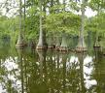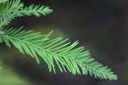

Beautyberry

Beautyberry is a rounded, bushy, multi-stem shrub that measures 6' to 8' tall. It has many spreading, oppositely arranged branches. The leaves are simple, opposite, and deciduous. They are usually 3" to 7" long and 1" to 3½" wide and ovate in outline. Both leaf surfaces are covered with short hairs and the leaf margins are serrate. The fruit is a fleshy, spherical drupe about 1/8" wide and is purple to violet, or rarely white. The small fruit occurs in dense clusters that surround the stem.

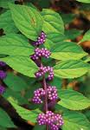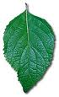

Black-eyed Susan
The black-eyed Susan, sometimes an annual, sometimes a perennial, and sometimes a biennial (flowering in its second year, then dying). This is a member of the huge aster or composite family, and has the typical daisylike flowerheads consisting of an outer ring of ray florets and a central receptacle composed of many disk florets. Black-eyed Susans typically stay in a basal rosette their first year, and then produce upright branching stems with flowers in their second year. The rough-textured basal leaves are diamond shaped, 4-7 in (10-18 cm) long, and have three conspicuous veins. When she's ready, black-eyed Susan produces erect, bristly stems to 3 ft (0.9 m) tall, which branch freely and bear hairy lance shaped leaves, 2-3 in (5-7.6 cm) long.
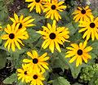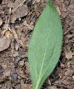

Coontie
Coontie is a small palmlike perennial plant that grows to a height of about 3 ft (0.9 m). Coontie forms a colony of suckers that slowly grow into mounds 5-6 ft (1.5-2.1 m) wide. The glossy dark green pinnate leaves are 3 ft (0.9 m) long with narrow pinnae (leaflets) 4-6 in (10.2-1.8 cm) long by 0.25 in ( cm) wide. This species is dioecious, having male or female reproductive parts (called "cones") present on separate plants. In late winter the rusty-brown male and female cones emerge from the ground. Males produce pollen that fertilizes the female cones that mature in autumn when the shiny red seeds are released.
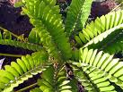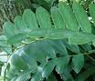

Live Oak Tree
Live oak is a large tree that reaches heights of 65' to 85'. It has a wide spreading crown and is buttressed and flared at the base of the trunk. The leaves are simple, alternately arranged, and may persist on the tree through winter until they gradually fall as new leaves emerge in the spring. The leaves are 2" to 5" long by ½" to 2 ½" wide. The narrowly to broadly elliptical shaped leaves are usually stiff and leathery. The upper surface is shiny, dark green. The leaves are dull grayish green underneath. The leaf base is tapering and the tip is short pointed to rounded. The margin is smooth and slightly wavy.
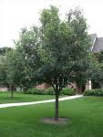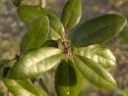

Muscadine grape
Muscadines are vigorous, deciduous vines growing 60-100 ft. in the wild. The slightly lobed, 2-1/2 to 5 inch leaves are rounded to broadly ovate with coarsely serrate edges and an acuminate point. Dark green above and green tinged yellow beneath, the leaves are glossy on both sides, becoming firm and subglabrous at maturity. Muscadines are dioecious, with male and female flowers on different plants. The small, greenish flowers are borne in short, dense panicles.
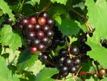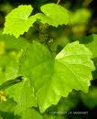

Red Bay (Florida Mahogany)
Red Bay is a member of the Laurel family. Red Bay sports the characteristic, spicy scent of Bay trees. The plant's characteristic scent is emitted when the leaves are crushed. Red Bay is also known as Florida Bay or Florida Mahogany. Red Bay is usually a tree that is usually 20 to 30 or 35 feet high, although it may sometimes grow to around 40 or 45 feet high. The leaves are pointed and rounded.

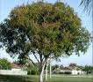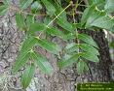

Saw-grass
Saw-grass is so named because it has spiny, serrated leaf blades that resemble a saw. It is the species that inspired the phrase 'river of grass' and is often referred to as Everglades river grass. Saw-grass is actually a sedge, not a true grass. Saw-grass is a tall, coarse-leafed, perennial sedge that grows to heights of 9'. The leaves are long, thin, flat blades with sharp, toothed serrations along the margins and on the underside of the midvein. The leaf blades are stiff and fold inward along the midvein. Leaves are greenish-brown in color and have loose, over-lapping sheaths.

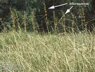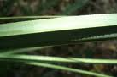
Saw Palmetto
Saw palmetto is named for the saw-toothed leaf stems that are very sharp. It is a branched, hardy, fan palm that measures two to nine feet tall. Its stem usually remains below ground or runs horizontally along the surface. In some cases, it develops an upright or arching stem. The leaves spiral around the stem. They are circular in outline and are usually 2' to 3' across. They are deeply divided into many dagger-shaped segments. The leaf stems are about 2' to 3' long and sharply saw-toothed.
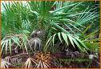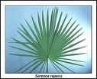

Wax myrtle
The simple narrow leaves of the wax myrtle range from 1-5 in (2.5-13 cm) in length and about 0.5 in ( 1.3 cm) wide. They are gray-green to yellow-green and aromatic when crushed. If you look at the leaf surface under magnification you'll see that it is covered with tiny yellow glands. Wax myrtle sends up multiple trunks that can grow to as high as 25 ft (7.6 m) and will eventually form a colony if suckers are not removed. The flowers appear in late winter. The males are yellow-green catkins that grow up to 1 in (2.5 cm) long while the females are small and inconspicuous little bumps that grow into small blue berries, 1/8 in (0.3 cm) in diameter, that are held closely to the stem.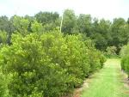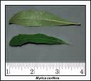

Invasive Plants

What is an invasive? Of the more than 4,000 plant species in Florida, perhaps 1,000
species or more (25%) are non-native; they’re also referred to as "exotic." An
invasive plant is a non-native plant species that has escaped cultivation, is spreading
on its own and causing environmental or economic harm. Non-native Invasive plants
can outgrow, replace, and otherwise destroy our native plants. That's because non
native plants usually do not have their natural enemies -- the diseases, insects and other environmental stresses -- that keep them in check in their native ranges.

Australian Pine Tree
Long-favored for use in erosion control along beaches, the Australian Pine Tree is now outlawed in many parts of Florida due to its invasive nature, rapid growth rate, and non-native status. It is not a true pine tree. Trees can grow to over 100 ft. (30.5 m) in height. The reddish-brown to gray bark is brittle and peels. Branchlets resemble pine needles and are very thin, 4-8 in. (10-20 cm) long and gray-green. Male and female flowers are present on the same plant and are inconspicuous. Male flowers occur in terminal spikes, while the female flowers are in small, axillary clusters. Fruit are tiny, winged nutlets that each contain one seed. The fruits are contained in woody, cone-like structures that are ¾ in. (2 cm) long. Australian pine is native to Australia and southeast Asia and was introduced into Florida in the late 1800’s.

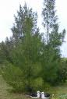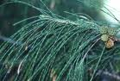

Brazilian Pepper Tree
Brazilian pepper-tree is a shrub or small tree that reaches over 30 feet in height, typically with a short trunk hidden in a thicket of branches. Some trees can live over 30 years. The leaves are alternately arranged with 1-2 inch long, elliptic, and finely toothed leaflets. The leaves are also reddish, often possessing a reddish mid-rib. The flower clusters are white and 2-3 inches long with male and female flowers that look very similar. The glossy fruits are borne in clusters that are initially green, becoming bright red when ripe. Seeds are dark brown and 0.3 mm in diameter. Flowering occurs from September through November and fruits are usually mature by December. Due to its invasive nature, it is placed by the Florida Department of Environmental Protection under section 62C-52.011 as a Class I -“Prohibited Aquatic Plant.” This law prohibits sale and or movement of this species.

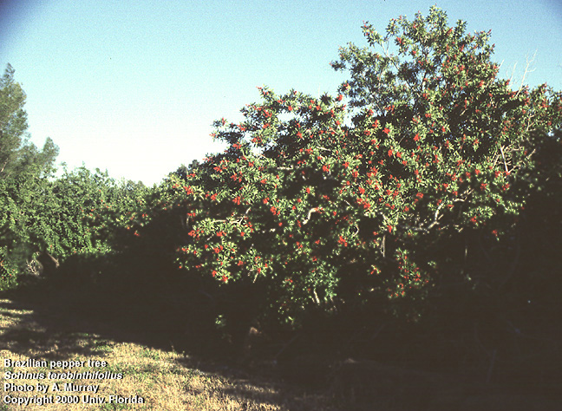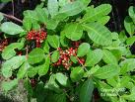

Earleaf Acacia
The earleaf acacia is an evergreen, unarmed tree to 15 m (50 ft) tall, with compact spread, often multi-stemmed; young growth glaucous. The leaves are alternate, simple, reduced to flattened blade-like phyllodes slightly curved, 11–20 cm (5–8 in) long, with 3–7 main parallel veins and a marginal gland near the base; surfaces dark green. The flowers are loose, yellow-orange spikes at leaf axils or in clusters of spikes at stem tips; flowers mimosa-like, with numerous free stamens.
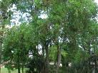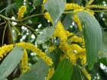

Melaleuca
is a genus of plants in the myrtle family . There are well over 200 recognized species, most of which are endemic to Australia. The species are shrubs and trees growing (depending on species) to 2–30 m (6.6–98 ft) tall, often with flaky, exfoliating bark. The leaves are evergreen, alternately arranged, ovate to lanceolate, 1–25 cm (0.39–9.8 in) long and 0.5–7 cm (0.20–2.8 in) broad, with an entire margin, dark green to grey-green in color. The flowers are produced in dense clusters along the stems, each flower with fine small petals and a tight bundle of stamens; flower color varies from white to pink, red, pale yellow or greenish. The Australian melaleuca tree was imported into South Florida in the early part of the century to dry out "worthless swampland" and transform it into lumber-producing forests. Today the melaleuca is scattered over 2,000,000 acres of South Florida. There has been an ongoing eradication program since 1984.
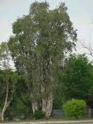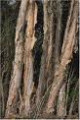

Soda Apple
Tropical soda apple is a native to Brazil and Argentina. It is in the family Solanaceae, or Nightshade family. This family also contains potato, eggplant, and tomato. It is an herbaceous perennial, growing 3-6 feet tall. Leaves are pubescent, deeply divided into pointed lobes. White to yellowish thorns up to 0.4 inch-long are found on the stems, flower stalks, leaves (both upper and lower surfaces), and calyxes. Flowers are white with yellow stamens and are found on the stem below the leaves. Fruits are globular in shape and are green in color when young, yellow at maturity. Tropical soda apple is extremely prolific, producing roughly 40,000 to 50,000 seeds per plant. Seed is spread primarily via livestock and wildlife, such as raccoons, deer, and birds that consume the fruit. This concern and its rapid spread throughout Florida caused it to be placed on the Florida Noxious Weed List in 1994 and the Federal Noxious list in 1995.
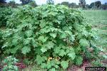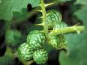

Poisonous Plants
Unfortunately, Florida has many poisonous or toxic plants. A few are included here:

Allamanda
Evergreen, sprawling shrub or woody climber; leaves opposite or whorled, simple, glossy, leathery; flowers tubular, yellow, in clusters at ends of branches. Allamanda plants are poisonous and produce a toxic milky sap when cut. Wear protective clothing — gloves, long-sleeve shirt and long pants — when pruning or you may develop a burning, itchy rash and possibly blisters.

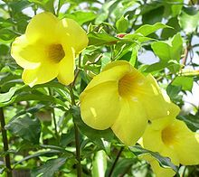

Angel’s Trumpet
Angel’s Trumpet are large shrubs or small trees, reaching heights of 3–11 m, with tan, slightly rough bark. The leaves are alternate, generally large, 10–30 cm long and 4–18 cm broad, with an entire or coarsely toothed margin, and are covered with fine hairs. The name Angel's Trumpet refers to the large, very dramatic, pendulous trumpet-shaped flowers, 14–50 cm to 20 inches long and 10–35 cm across at the wide end. They are white, yellow, pink, orange or red, and have a delicate, attractive scent with light, lemony overtones, most noticeable in early evening. Flowers may be single or double.
All parts of Angel’s Trumpet is highly toxic. The plants are sometimes ingested for recreational or shamanic intoxication as the plant contains the tropane alkaloids scopolamine and atropine; however because the potency of the toxic compounds in the plant is variable, the degree of intoxication is unpredictable and can be fatal. Deaths have been reported from teas made from the plant.

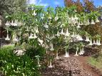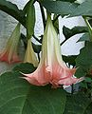

Castor Bean
The castor bean plant is a native of tropical Africa cultivated in several varieties for the oil found in its leaves and for its bold foliage. The stalked leaves consist of usually eight radiating, pointed leaflets with slightly serrated edges and prominent central veins. Many varieties are green, but some are reddish brown. The flowers are green and inconspicuous, but pink or red in the pigmented varieties. Many stamens are near the base and branching pistils are near the top of the flower. The soft-spined fruits containing attractively mottled seeds are distinctive features of the plant.
The seeds from the castor bean plant are poisonous to people, animals and insects. Poisoning by ingestion of the castor bean is due to ricin. The symptoms of human poisoning begin within a few hours of ingestion. The symptoms are: abdominal pain, vomiting, and diarrhea, sometimes bloody. Within several days there is: severe dehydration, a decrease in urine, and a decrease in blood pressure. If death has not occurred in 3-5 days, the victim usually recovers.

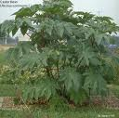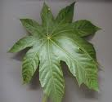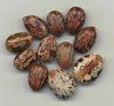

Oleander
Oleander is an evergreen shrub or small tree in the dogbane family. It is most commonly known as oleander but has many other names. Oleander grows to 2–6 m (6.6–20 ft) tall, with spreading to erect branches. The leaves are in pairs or whorls of three, thick and leathery, dark green, narrow lanceolate, 5–21 cm (2.0–8.3 in) long and 1–3.5 cm (0.39–1.4 in) broad, and with an entire margin. The flowers grow in clusters at the end of each branch; they are white, pink, red or yellow, 2.5–5 cm (0.98–2.0 in) diameter, with a deeply 5-lobed corolla with a fringe round the central corolla tube. They are often, but not always, sweetly scented.

Although it is a common landscape plant, Oleander is one of the most poisonous plants in the world and contains numerous toxic compounds, many of which are deadly to people, especially young children. The toxicity of oleander is considered extremely high, and it has been reported that in some cases only a small amount had lethal or near-lethal effects. The entire plant, including the nectar is toxic, and any part can cause an adverse reaction. Oleander is also known to hold its toxicity even after drying. It is thought that a handful or 10-20 leaves consumed by an adult can cause an adverse reaction, and a single leaf could be lethal to an infant or child. According to the Toxic Exposure Surveillance System (TESS) in 2002 there were 847 exposures to oleander reported to poison centers in the United States. There are innumerable reported suicidal cases of consuming mashed oleander seeds in southern India. Around 0.23 mg per pound of body weight is lethal to many animals, and various other doses will affect other animals. Most animals can suffer a reaction or death from this plant.
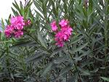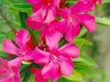

Philodendron
This is a popular group of plants that are grown for their ornamental foliage. They are mostly climbing plants that can be grown in homes, greenhouses, and in the far South, outside. Under good conditions, they will bear pretty "flowers" that resemble Calla Lilies. They are found wild in tropical America and the West Indies. These plants have long aerial roots and come in many shapes and sizes. Most of the plants have rich green leaves but some may be coppery-red underneath or have veins that are red. Some leaves are red when they are young but eventually turn green. Some kinds have heart-shaped leaves, others have long and narrow leaves, some are arrow-shaped, oblong, ovate or deeply lobed. Their size varies from 3 inches to 3 feet in length. The inflorescences (flowers) have spathes that come in different shades of purple, pink, red, or greenish-white. The central columns that bear the tiny flowers (spadices) can either be yellow, cream or white.

Philodendron poisoning occurs when someone eats pieces of this plant Symptoms include: Burning and painful eyes , burning in mouth and throat, diarrhea, irritated skin, nausea, slurred speech, swelling of mouth, swelling of tongue, vomiting

